Chapter 17, Problem 81.

Consider the full-wave rectified sinusoidal current in Table 17.3. Assume that the current is passed through a 1-Ω resistor.

- Find the average power absorbed by the resistor.
- Obtain c_{n} for n = 1, 2, 3, and 4.
- What fraction of the total power is carried by the dc component?
- What fraction of the total power is carried by the second harmonic (n = 2)?

Table 17.3 The Fourier series of common functions.
Function | Fourier Series
1. Square wave
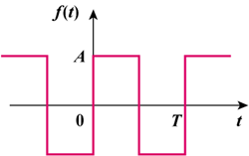 | 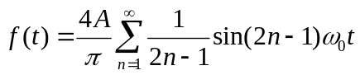
2. Sawtooth wave
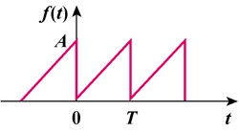 | 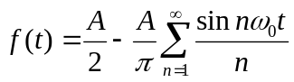
3. Triangular wave
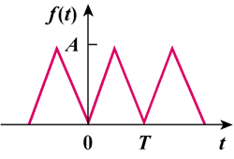 | 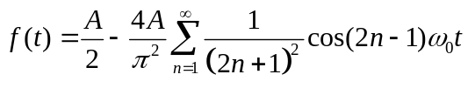
4. Rectangular pulse train
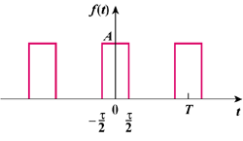 | 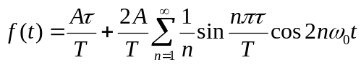
5. Half-wave rectified sine
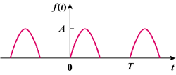 | 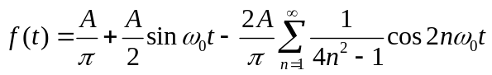
6. Full-wave rectified sine
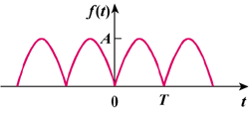 | 